Lab 2
NAT and PAT
Objective:
The purpose of this lab is for the student to understand, create and implement NAT and PAT. Students will also utilize IOS commands to explore and configure NAT and PAT on a network router.
Diagram:
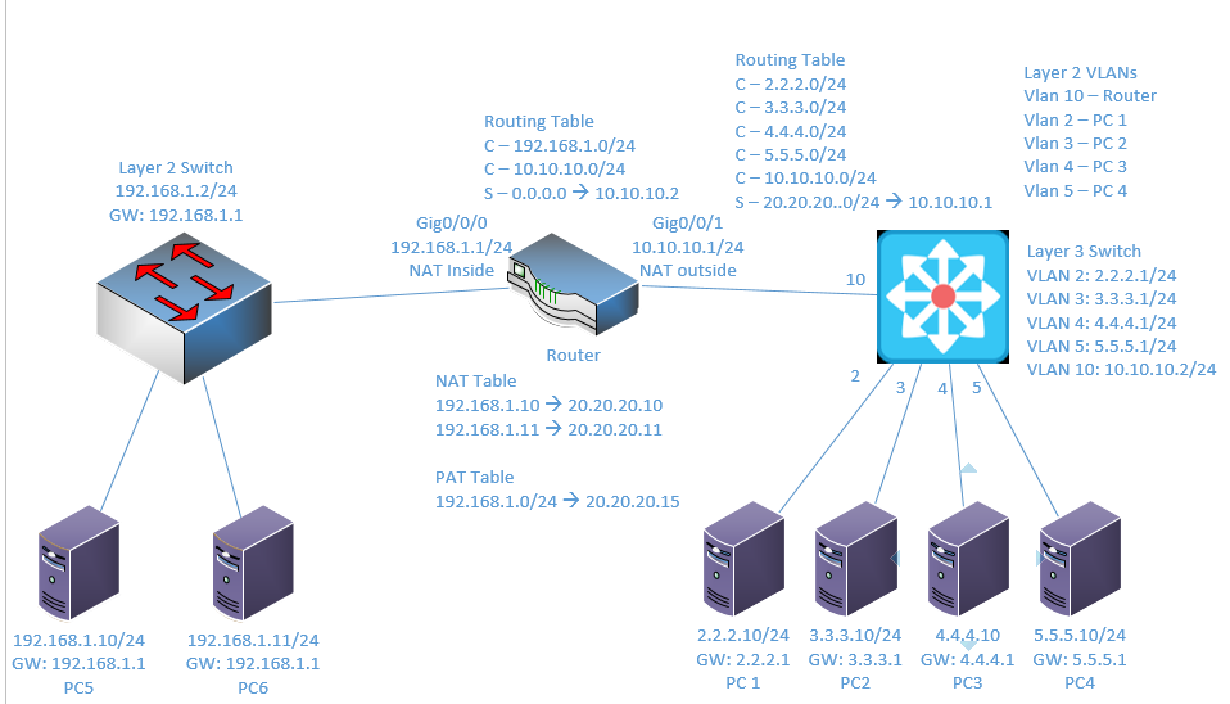
Components:
6 – PC’s with an Ethernet NIC
1 – Layer 3 Switch
1 – Layer 2 Switch
1 – 2 Port Router

Useful commands for this lab:
show ip route – view routing table
show vlan – View vlan table and port assignments
show ip interface brief – view status of layer 3 ports
show access-lists – view access lists and hit counters
show ip nat translations – view NAT table

Enable Telnet:
line vty 0 15
password telnetpassword – set telnet password
login – enable login process
access-class 10 in – apply access-list to vty (telnet)

Enable routing on Layer 3 switch
ip routing

Configure NAT
interface Gigabitethernet 0/0/0
ip nat inside
interface Gigabitethernet 0/0/1
ip nat outside

ip nat inside source static 192.168.1.10 20.20.20.10

Configure PAT
interface Gigabitethernet 0/0/0
ip nat inside
interface Gigabitethernet 0/0/1
ip nat outside

access-list 1 permit 192.168.1.0 0.0.0.255
ip nat pool natpool 20.20.20.15 20.20.20.15 netmask 255.255.255.0
ip nat inside source list 1 pool natpool overload

Create Static route – Entire 20.20.20.0/24 network to 10.10.10.1

ip route 20.20.20.0 255.255.255.0 10.10.10.1

Create standard ACL (1-99)

access-list 5 permit 7.7.7.0 0.0.0.255
access-list 5 permit 9.9.9.0 0.0.0.255

Procedure:
- Using the diagram above, connect all PC’s to their appropriate switches and put their static IP addresses, subnet masks and gateways on them. Test connectivity between the two PCs on 192.168.1.0/24 network using ping. The others won’t ping successfully yet.

- Using the diagram above label the Layer 3 switches VLAN IP addresses and ports below

Layer 3 Switch
VLAN | IP | Switch Port
2 | 2.2.2.1/24 | 1
3 | 3.3.3.1/24 | 2
4 | 4.4.4.1/24 | 3
5 | 5.5.5.1/24 | 4
10 | 10.10.10.2/24 | 24

- Using the diagram above label the routing tables for the Layer 3 switch and router below.

Router | Layer 3 Switch
C – 192.168.1.0/24 | C – 2.2.2.0/24
C – 10.10.10.0/24 | C – 3.3.3.0/24
S – 0.0.0.0 -> 10.10.10.2 | C – 4.4.4.0/24
 | C – 5.5.5.0/24
 | C – 10.10.10.0/24
 | S – 20.20.20.0/24 -> 10.10.10.1

- Place the switch ports into the proper vlans. Configure all of the switches vlan IP addresses.
  - Example: Make sure to adjust the port number, vlan number and IP address to match your task. This is just an example.
interface Gigabitethernet 1/0/1
switchport mode access
switchport access vlan 2
no shutdown
interface vlan 2
ip address 2.2.2.1 255.255.255.0
no shutdown

- Enable routing on the Layer 3 switch

- View the routing table on the Layer 3 switch

- Verify that the PC’s on the Layer 3 switch can ping each other

- Configure the IP addresses on the router interfaces and turn the interfaces on. Remember that router interfaces are shut down by default. You’ll need to do a “no shutdown” to turn them on.

- View the routing table on the Layer 3 switch

- Place a static route on the Layer 3 switch to send traffic destined for 20.20.20.0/24 network to 10.10.10.1. Do not add a default route or a route to the 192.168.1.0/24 network

  - What command did you enter?
Ip route 20.20.20.0 255.255.255.0 10.10.10.1

- Place a static, default route on the router to 10.10.10.2. Remember, the default route is the “all zeros” route.

  - What command did you enter?
Ip route 0.0.0.0 0.0.0.0 10.10.10.2
- Can 192.168.1.10 ping 2.2.2.10?
No
  - Why? Remember, some tests are unsuccessful by design.
The layer 3 switch does not have a way to send the traffic back to the 192 network.

- Make the router interface with 192.168.1.1/24 a NAT inside interface

  - What commands did you enter?
Int gi0/0/0
Ip nat inside

- Make the router interface with 10.10.10.1/24 a NAT outside interface

  - What commands did you enter?
Int gi0/0/1
Ip nat outside

- Create static NAT translations for
  - 192.168.1.10 to be translated as 20.20.20.10
  - 192.168.1.11 to be translated as 20.20.20.11
  - What commands did you enter?
Ip nat inside source static 192.168.1.10 20.20.20.10
Ip nat inside source static 192.168.1.11 20.20.20.11

- Can 192.168.1.10 ping 2.2.2.10?
Yes
  - Why? The router translates 192.168.1.10 to 20.20.20.10, and it knows where to route the 20 network traffic on the way back from the ping.

- Can 2.2.2.10 ping 192.168.1.10?
No
  - Why? The router does not know where to route the ping back to the 192 network.

- Can 2.2.2.10 ping 20.20.20.10?
Yes
  - Why? The router knows where to route the ping back to the 20 network and translates the destination to the 192 network.

- View the NAT Translation table on the router

  - What command did you enter?
Show ip nat translations

  - What entries do you observer?
Pro Inside global Inside local Outside local Outside global
--- 20.20.20.10 192.168.1.10 --- ---
--- 20.20.20.11 192.168.1.11 --- ---

- Remove the static NAT translations for:
  - 192.168.1.10 to be translated as 20.20.20.10
  - 192.168.1.11 to be translated as 20.20.20.11

  - What commands did you enter? Remember most Cisco commands can be removed by putting the word “no” in front of them.
No ip nat inside source static 192.168.1.10 20.20.20.10
No ip nat inside source static 192.168.1.11 20.20.20.11

- Create a standard access list 5 allowing 192.168.1.0/24

  - What command did you enter?
Access-list 5 permit 192.168.1.0 0.0.0.255

- Create a NAT pool with a name of netcom a range of 20.20.20.15 to 20.20.20.15 and a class C netmask. it’s okay to create a pool with the same beginning and ending address in the nat pool.

  - What command did you enter?
ip nat pool netcom 20.20.20.15 20.20.20.15 netmask 255.255.255.0

- Create a PAT translation using access-list 5 and NAT pool Netcom

  - What command did you enter?
Ip nat inside source list 5 pool netcom overload

- Can 2.2.2.10 ping 20.20.20.15?
No
  - Why? The router does not have a NAT translation for 20.20.20.15

- Can 192.168.1.10 ping 2.2.2.10?
Yes
  - Why? The NAT translation was created for the 192 network when the traffic flowed out of the 192 network.

- Can 2.2.2.10 ping 20.20.20.15?
Yes
  - Why? The NAT translation from before is in the NAT table now
  - What is different than before? The routing table was updated with the new information and the route was completed.

- View the NAT Translation table on the router

  - What command did you enter?
Show ip nat translations

  - What entries do you observer?
Pro Inside global Inside local Outside local Outside global
icmp 20.20.20.15:22 192.168.1.10:22 2.2.2.10:22 2.2.2.10:22
icmp 20.20.20.15:23 192.168.1.10:23 2.2.2.10:23 2.2.2.10:23
icmp 20.20.20.15:24 192.168.1.10:24 2.2.2.10:24 2.2.2.10:24
icmp 20.20.20.15:25 192.168.1.10:25 2.2.2.10:25 2.2.2.10:25

- Draw the lab diagram below using either Visio or Packet Tracer. It should look similar to mine above but should NOT be a copy and paste of mine in Packet Tracer or Visio. Label the IP addresses, subnet masks, and gateways used by each device. Label the routing tables next to the switch and router and the switches vlan IP addresses and port vlan information. Label the NAT and PAT translations next to the router.

